CURICULUM VITAE
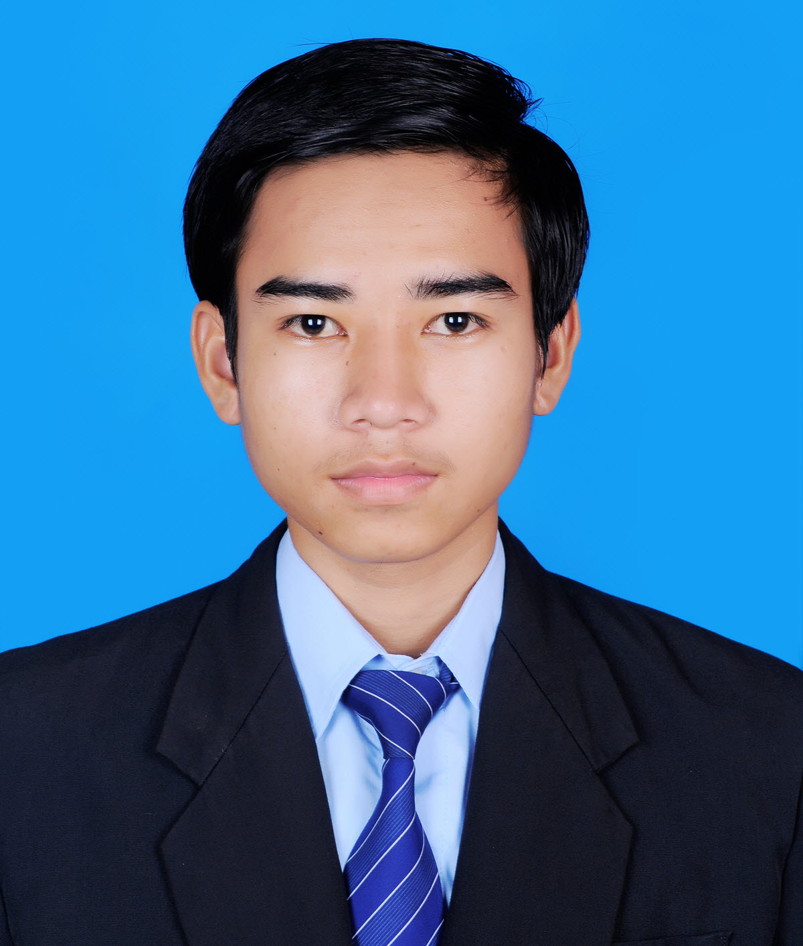

4×6
Mr. Lim Chhunly
#09, St G3, Dey Thmey village,
Sangkat Phnom Penh Thmey, Khan Sen Sok, Phnom Penh
Tel : 096 88 52 699
E-mail: chhunly.smart@gmail.com

PERSONAL DATA
Sex : Male
Date of Birth : March 18, 1994
Place of Birth : Kampong Leng District, Kampong Chhnang Province, Cambodia
Nationality : Khmer
Marital Status : Single
Health Situation : Excellent

EDUCATION BACKGROUND

Present : Attending Bachelor Degree of Computer Science and Engineering in Faculty of Science at Royal University of Phnom Penh (Year IV).

2010- 2013 : Soramrith High School, Kampong Chhnang city, Kampong Chhnang province.

2009-2010 : Hun Sen Kampongleng High School, Kampong Leng District, Kampong Chhnang province.

2007-2009 : Chok Chey Chronouk Secondary School, Kampong Leng district, Kampong Chhnang province.

TRAINING COURSES

01 May, 2016 – present : IT training at KSHRD
05 June – 04 Oct, 2010 : Have successfully completed of Grammar For Writing at BOREY VICHEA English Center, Kampong Chhnang province.
03 Jan- 25 Nov, 2011 : Have successfully completed of a course in Upper Intermediate at PREAH KUN Computer & English Center.

LANGAUGE SKILLS
Khmer : Mother Tongue
English : Good at writing, speaking, listening, and reading
Korean : Fair

WORKING EXPERIENCE

26 May, 2015 -15 Mar, 2016 : 3D Designer at Digital Work Entertainment (Khmer Branch)

REFERENCE

Name : Mr. MAN PHEAREAK
Position : An official of the Ministry of Plan.
Tel : 012 93 27 98
Email : pheareak@outlook.com

Name : Mr. HIM KHEMRA
Position : Battambang Class leader
Tel :
Email :

